

Space, Range and Display

Solution Architecture

Project BEN Code: | W60336
Author: | John Cowper & Jim Jeffery
Date: | 16-03-2007
Version: | 0.0.12
Status: | Draft
Level: | High Level

Table of Contents
1 Introduction 3
1.1 Management summary 3
1.2 Benefits 3
1.3 Scope 4
1.4 Tesco Enterprise Architecture 5
1.5 Related Document 6
1.6 Project Versions 6
2 Conceptual Architecture (optional) 8
2.1 Conceptual program level architecture diagram 8
2.2 Rationale for architecture 8
3 Logical Architecture (optional) 10
3.1 Logical Application Architecture 10
3.2 Logical Information Architecture 13
3.3 Logical Infrastructure Architecture 20
4 Physical Architecture 23
4.1 Physical Application Architecture 23
4.2 Data Centre Based Systems 23
4.3 Store Based (Retail) Systems 25
4.4 Reporting Systems 26
4.5 Enterprise Information & Integration Services Layer 26
4.6 Physical Information Architecture 27
4.7 Physical Infrastructure Architecture 27
5 Deployment Architecture 28
6 Development Architecture 29
6.1 Development Environments 29
6.2 Development Tools 29
6.3 Development Method 30
6.4 Implementation Considerations 30
7 Operations Architecture 31
7.1 Infrastructure 31
7.2 Applications 31
7.3 Information and Integration 32
7.4 Business Processes 32
8 Assumptions and Issues 33
8.1 Assumptions 33
8.2 Architecture Principles and Exceptions 33
8.3 Risks 34
9 Appendix 35
9.1 Requirements Traceability 35
9.2 Document Control 35

Introduction

Management summary

- Space, Range & Display covers:
  - Creating and maintaining space allocations for all new and existing stores
  - Building ranges & planograms for all store formats, sizes and profiles
  - Implementing space, range & planogram changes in store
  - Managing & maintaining all central and store processes, systems & information needed to support these activities
- The key benefits are that:
  - We use our space optimally, ensuring we have the right product categories available to customers
  - We have ranges which are relevant for customers
  - The displays on our fixtures make shopping easy for customers and support the operation
  - Processes are simple for stores and enable stores to implement changes accurately and on time
- Our main dependencies are with:
  - Commercial: to ensure that space, range & display systems link with the product file & product hierarchy
  - Supply chain & distribution: to ensure the right ranges get delivered to the right stores on time, and that the ordering systems use the correct capacities
  - Store operations: to ensure stores have all the information they need to carry out all space, range & display activity
  - Property: to ensure all new stores, extensions and refits receive the right space, ranges & planograms
  - MIS: to ensure that group management information solutions include space, range & display reporting, and to ensure that management information is available to space, range & display systems
- Key decisions to be made include:
  - What are the best practice systems for space, range & display?
  - What is the impact of Central European buying and any regional buying in China on space, range & display processes?
  - What is the right hand-over point with Property for creation of floor plans for new stores, extensions & refits?
  - Who owns ‘planning new & discontinued lines’ - Supply Chain or Space, Range & Display?
  - Where will depot & store range records be held? Where will capacities be calculated & held?

Benefits
1) Set space allocations
- We optimise the use of our space to ensure we:
  - can carry the right breadth and depth of product categories to satisfy our customers
  - give the right amount of space to each category to support efficient replenishment/stockholding
2) Build ranges and planograms
- We ensure that we are Number 1 for range through:
  - Creating ranges which appeal to all customers
  - Targeting our ranges to match the customer profile of each store
- We build planograms which:
  - Make shopping easy for customers
  - Support efficient replenishment/stockholding
  - Enable good availability and support the customer promise of ‘I can get what I want’
3) Implement space, range & display changes in store
- We ensure ranges and fixtures in store remain relevant for customers through scheduled range reviews
- We ensure ranges and fixtures in store remain fit for the replenishment operation

Space, range & display drives sales and enables efficient replenishment

Scope
Space, Range and Display is a component of the (Tesco) Operating Model. This is attached below.

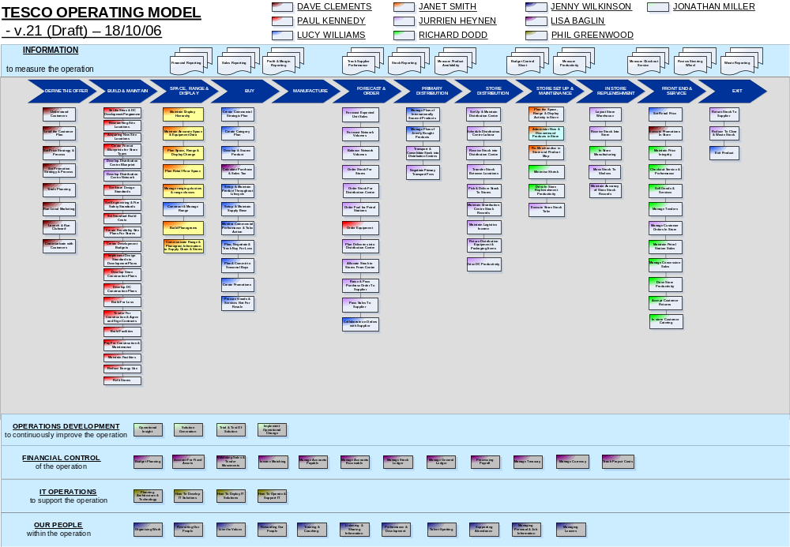
Fig n – The Operating Model
.
The execution of Space, Range and Display occurs in the ‘Space, Range and Display’ and ‘Store Set Up & Maintenance’ Level 0 Business Processes. Specifically this covers the Level 1 Business Processes:
Space, Range and Display
- Maintain Display Hierarchy
- Maintain Accurate Space and Equipment Data
- Plan Space, Range and Display Change
- Plan Retail Floor Space
- Manage ranging clusters & range classes
- [Construct and Manage Range]
- Build Planograms
- Communicate Range and Planogram Information to Supply Chain and Stores
Store Set Up and Maintenance
- Plan the Space, Range & Display Activity in Store
- Administer New & Discontinued Products in Store
- Re-Merchandise in Store and Product Map
- [Minimise Shrink]
- [Drive in Store Replenishment Productivity]
- [Execute Store Book Take]

Those items marked […] are activities within the Space Range and Display environment which are owned by other functional teams.

The scope can then be summarised as:

In scope | Out of scope
- TOM  - US  - Turkey  - Food | - Hardlines  - Business analysis to enable Clothing

The TOM SRD project encompasses the design and development of new and existing systems to support:
- The creation, planogramming and authorising of generic ranges for defined display groups in conformance with the Space, Range and Display schedule
- The maintenance of Store Clusters (previously known as Store Range Groups), based on variable attributes such as country, format and ethnicity.
- The identification of overlay products and the standard products they will replace in selected stores
- The dissemination of authorised generic ranges, including overlays, and the store groupings to which they relate.

Tesco Enterprise Architecture
The Tesco Enterprise Architecture is appended below.

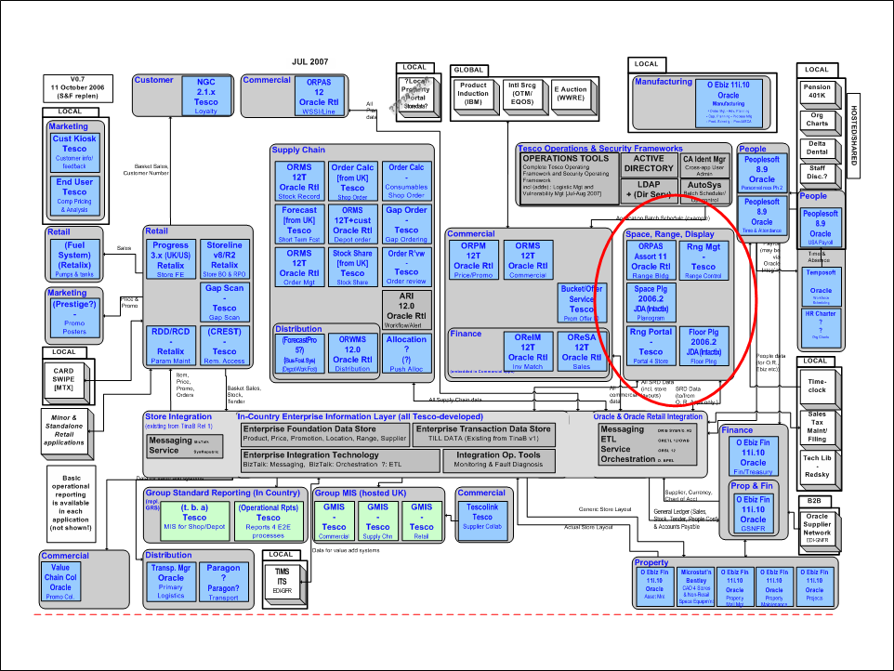
Fig n: Tesco Enterprise Application Architecture (v0.10 US)

Related Document
Include all documents that are referred to in this document. This should include the Requirements Document, and later, the Business System Design, along with any Exception Compliance Plans

Author | Date | Version | Title
 | dd mmm yyyy | v0.1 Draft

Project Versions
Due to the compacted timeframes for the delivery of this project an amount of prioritisation has been done. The projects functional scope has been split into 2 versions that will be delivered separately. The projects functionality is both summarised and defined in terms of Business Services (that are described later in the document) and the project versions are defined by listing the Business Services to be implemented in it.

Version 1 covers the application priorities of:

JDA – Priority 1
Product Mapping – Priority 2
Store Range – Priority 2
Sales Aggregation – Priority 2
Range Controls – Priority 3
Range Planning – Priority 3
Ranges in Progress – Priority 3
Operational Reporting – Priority 4
MIS Reporting – Priority 4

Version 2 covers the application priorities of:
Local Ranging – Priority 5
Store Portal – Priority 6

The following section lists the business services contained within the version releases:

Project Version 1 Supported Business Services

- Creating floor plans manually
- Creating generic planograms
- Publishing floor plans/planograms to stores
- Calculating store-specific ranges & store-specific impact of range changes
- Providing range indicators for shelf edge labels
- Capturing actual space, range & capacity information through product mapping
- Creating the actual product map in stores (product in location)
- Managing display hierarchy
- Assigning store clusters to display groups
- Creating ranges & basic range modelling
- Managing store clusters
- Passing ranges to planogram system & managing workflow
- Reconciling ranges and planograms
- Scheduling events: range changes
- Scheduling events: promotions
- Setting the space-to-range class relationship
- Managing the retail settings & controls
- Reporting (management)

Project Version 2
- Space Range and Display Portal
- Managing overlays

Conceptual Architecture (optional)

Conceptual program level architecture diagram
The following diagram illustrates the program level end state architecture. It is probable that the property components will not be delivered in the first phase.

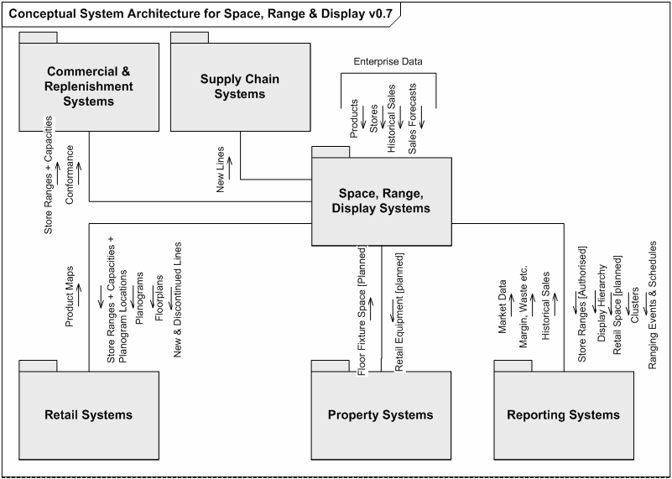
Fig n. Conceptual Architecture for Operating Model Program

Rationale for architecture
This section describes how the proposed architecture was arrived at.

Conceptual Architecture
The TOM Space, Range and Display Architecture is anchored against the UK Space, Range and Merchandising development. At the time of writing the UK system had just gone live with the first Merchandising Hierarchy (end 2006). In this sense, the conceptual architecture is derived from working practice rather than being developed from a set of business requirements. Workshop activities have been undertaken to establish the potential fitness for purpose of the UK solution for other countries and this has demonstrated a relatively high degree of match.

A number of other products were assessed as part of this exercise but none were as sufficiently good a match as this chosen option. Details of the product comparisons and the ranking process are available. A broader range of planogramming tools were assessed and JDA was deemed to be the most suitable. JDA is already in use in the UK model and the familiarity of this tool has helped its adoption in TOM.

There are clearly significant differences between the UK requirements and any other country: language, platform, absence of or different legacy systems. The TOM solution also extends the UK solution in that it will also encompass a floor planning component.

The conceptual architecture aims to design an holistic model which is then tailored to the constraints of the target country.

Functional Requirements
The functional requirements are being established as the functionality of the UK system modified where necessary with Change Requests. The requirements are also being documented stream by stream within Business Requirement Definitions and SIPOCS maps. This document describes the solution in terms of business services and these need to be sufficiently well described to confirm that the business requirements can be satisfied. The business requirements are currently not documented but will be contained and matrix referenced in the Detailed Solution Architecture.

Benefits
The benefits of the delivery are that the initial Operating Model candidates (Turkey, US) will have a Customer facing solution that is fully integrated with the other supply chain, marketing and replenishment systems. This will allow the Country and Store management to manage space, construct ranges and display the appropriate product layouts with the associated shelf edge labels.

Risks
There are clearly risks in not having categorical business requirements stipulated but this needs to be balanced against the delivery timelines of the overall Operating Model program. The timeline and scope of the overall program itself is a substantial risk.

The systems themselves are also currently only delivered as a UK language model. The Ranges in Progress application is hardcoded (screens, messages, error messages) in English and will require a substantial amount of effort to recode. The remainder of the applications are built in .NET using local language files. Local language text will need to be created for each country and checked for presentation but is otherwise localisable.

It is recognised already that the proposed solution will be implemented with as few as changes as can be done. This is to constrain as tightly as possible the delivery time. There are consequences to this though that substantial rework will be required immediately the solution has gone in. There is a danger that this will be further delayed as there are other countries lined up to accept this solution. There is therefore a substantial risk that the remedial work is never completed and that ever more instances are deployed making it linearly more complicated to achieve a point where the application is substantially fit for purpose.

Logical Architecture (optional)

Logical Application Architecture
The following diagram gives an overview of the logical architecture of the solution. It groups areas of system functionality into logical “layers” and shows the required information flows between these layers. This is then used as a basis for identifying system services – wherever an interaction exists, one or more services will need to be provided to support it.

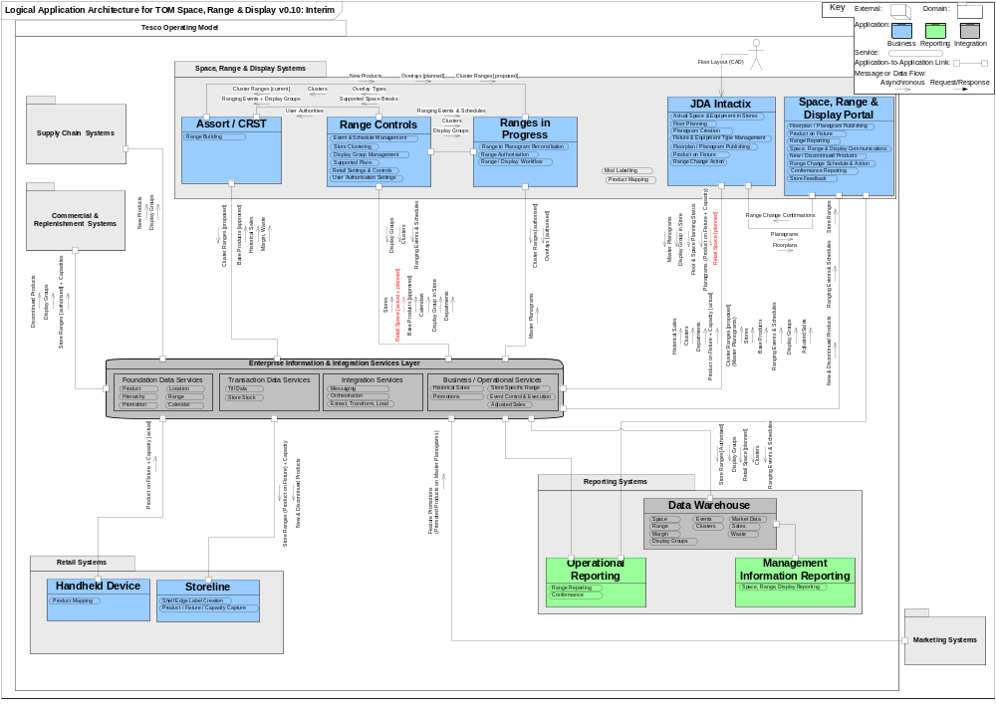Fig n – Logical Application Architecture for TOM SRD

This section describes the logical application architecture. The main components of the system are the SRD centric elements of

- Ranging System (Based on Oracle RPAS)
- Range Controls
- Ranges in Progress
- JDA Floor Planning & Planogramming
- Store Range
- Product Mapping
- Sales History Aggregation
- SRD Portal

The functionality of these components is described in the following sections.

Business services used
This section catalogues the Business Services that will be provided by the Space, Range and Display solution.

Business Service | Component Providing Service | Information Created / Updated | Information Required
Product / Fixture / Capacity Capture | Storeline | Product on Fixture [actual]
Shelf Edge Label Creation | Storeline |  | Product, Product on Fixture
Range Building | Ranging System | Cluster Range for Display Group for Range Class | Product, Event, Cluster, Display Group, Range Class, Overlay Type, Sales History
Event & Schedule Management | Range Controls | Event | Business Calendar
Store Clustering | Range Controls | Cluster, Overlay Type | Event, Store
Display Group Management | Range Controls | Display Group | Event, Product
Supported Plans | Range Controls | Range Class | Event, Cluster, Display Group
Retail Settings & Controls | Range Controls | ? | ?
Ranges to Planogram Reconciliation | Ranges in Progress |  | Event, Cluster Range for Display Group for Range Class, Planogram
Range Authorisation | Ranges in Progress | Cluster Range for Display Group for Range Class [authorised]
Range / Display Workflow | Ranges in Progress
Actual Space & Equipment in Stores | JDA Intactix | Fixture Type, Product on Fixture [actual] | Store, Product
Floor Planning | JDA Intactix | Floorplan, Planogram on Floorplan, Display Group in Store | Store, Planogram, Display Group
Planogram Creation | JDA Intactix | Planogram, Product on Fixture | Product, Display Group, Cluster, Equipment Type
Fixture & Equipment Type Management | JDA Intactix | Fixture Type, Equipment Type
Floorplan / Planogram Publishing | JDA Intactix |  | Store, Display Group, Floorplan, Planogram
Product on Fixture | JDA Intactix |  | Product, Planogram, Floorplan
Range Change Action | JDA Intactix | Event | Event
Product Mapping | JDA Intactix |  | Planogram, Floorplan, Product on Fixture [planned], Product on Fixture [actual]
Space, Range & Display Communications | Space, Range & Display Portal
New / Discontinued Products | Space, Range & Display Portal |  | Event, Product, Product on Fixture, Planogram, Planogram on Floorplan, Store
Range Change Schedule & Action | Space, Range & Display Portal |  | Event
Store Feedback | Space, Range & Display Portal |  | Event
Range Reporting | Space, Range & Display Portal, Operational Reporting |  | All
Space, Range & Display Reporting | Operational Reporting, Group MIS |  | All
Mod Labelling | Space, Range & Display Portal |  | Event, Product, Product on Fixture, Planogram, Planogram on Floorplan, Store
Historical Sales | Enterprise Information Services | Historical Sales [aggregated] | Historical Sales
Promotions | Enterprise Information Services | Planogram, Product on Planogram | Promotion
Store Specific Range | Enterprise Information Services | Planogram | Event, Product, Product on Fixture, Planogram, Planogram on Floorplan, Store, Display Group in Store
Event Control & Execution | Enterprise Information Services |  | Event
Adjusted Sales | Enterprise Information Services |  | Sales [adjusted]
User Authorisation Settings | Range Controls

Logical Information Architecture
Please refer to diagram above for detail. There is an intention to re-use existing UK interfaces where possible to reduce the time of delivery. Even where the interface is not re-usable any of the supporting data eg Technical Systems Design documents, Interface specifications will be cannibalised.

Data Flow | Source | Target | Information | Event (initiator) | Reuse | Develop
Cluster Ranges [proposed] | Ranging System | JDA Intactix | Cluster Range for Display Group for Range Class, plus aggregated historical sales for the Products, plus ‘placeholders’ for new Products not yet in RMS | When range building is completed |  | ✓
Base Products [approved] | Enterprise Information | Ranging System | Base Product | Overnight, on completion of pre-ranging |  | ✓
Historical Sales [adjusted pre-tax] | Enterprise Information | Ranging System | Sales History (aggregation varies) | Overnight, on completion of pre-ranging plus refresh until Range is submitted |  | ✓
Margin, Waste | Enterprise Information | Ranging System | Margin, Waste | Overnight
Cluster Ranges [current] | Range Controls | Ranging System | Cluster Range for Display Group for Range Class | Overnight, on completion of pre-ranging | ✓
Overlays [planned] | Ranging System | Ranges in Progress | Overlay | When range building is completed | ✓
Cluster Ranges [proposed] | Ranging System | Ranges in Progress | Cluster Range for Display Group for Range Class | When range building is completed | ✓
Stores | Enterprise Information | Range Controls | Store | When store is created / changed |  | ✓
Base Products [approved] | Enterprise Information | Range Controls | Base Product | When product is created / changed |  | ✓
Calendars | Enterprise Information | Range Controls | Business Calendar |  |  | ✓
Display Group in Store | JDA Intactix | Range Controls | Display Group in Store | When floorplan is changed |  | ✓
Departments | Enterprise Information | Range Controls | Department | When department is created / changed |  | ✓
Display Groups | Range Controls | Ranges in Progress | Display Group | When display group is created / changed | ✓
Display Groups | Range Controls | JDA Intactix | Display Group | When display group is created / changed |  | ✓
Display Groups | Range Controls | Data Warehouse | Display Group | When display group is created / changed |  | ✓
Clusters | Range Controls | Ranging System | Cluster | Overnight, on completion of pre-ranging | ✓
Clusters | Range Controls | Data Warehouse | Cluster | Overnight, on completion of pre-ranging |  | ✓
Clusters | Range Controls | Ranges in Progress | Cluster | Overnight, on completion of pre-ranging | ✓
User Authorities | Range Controls | Ranging System | User |  | ✓
Ranging Events + Display Groups | Range Controls | Ranging System | Event + Display Group + Display Group.products | Overnight, on completion of pre-ranging | ✓
Ranging Events & Schedules | Range Controls | Ranges in Progress | Event |  | ✓
Ranging Events & Schedules | Range Controls | JDA Intactix | Event | Overnight, on completion of pre-ranging |  | ✓
Ranging Events & Schedules | Range Controls | Space, Range & Display Portal | Event | Overnight, on completion of pre-ranging |  | ✓
Ranging Events & Schedules | Range Controls | Data Warehouse | Event | Overnight, on completion of pre-ranging |  | ✓
Supported Space Breaks | Range Controls | Ranging System | Range Class | Overnight, on completion of pre-ranging | ✓
Overlay Types | Range Controls | Ranging System | Overlay Type | Overnight, on completion of pre-ranging | ✓
Cluster Ranges [authorised] | Ranges in Progress | (Store Specific Range) | Cluster Range for Display Group for Range Class | When range is authorised | ✓
Overlays [authorised] | Ranges in Progress | (Store Specific Range) | Cluster Range for Display Group for Range Class | When range is authorised | ✓
Master Planograms | JDA Intactix | Ranges in Progress | Planogram | When range to planogram reconciliation is done |  | ✓
Floor & Space Planning Status | JDA Intactix | Ranges in Progress | Event | When object lifecycle changes occur |  | ✓
Planograms | JDA Intactix | Storeline | Planogram, Product on Fixture | When range is authorised |  | ✓
Historical Sales [adjusted pre-tax] | Enterprise Information | JDA Intactix | Sales History |  |  | ✓
Departments | Enterprise Information | JDA Intactix | Department | When department is created / changed |  | ✓
Product on Fixture + Capacity | Storeline | JDA Intactix | Product on Fixture | When scanned |  | ✓
Stores | Enterprise Information | JDA Intactix | Store | When store is created / changed |  | ✓
Base Products [approved] | Enterprise Information | JDA Intactix | Base Product | When product is created / changed |  | ✓
Sales [adjusted pre-tax] | Enterprise Information | JDA Intactix | Sales | Weekly |  | ✓
Store Ranges | (Store Specific Range) | Space, Range & Display Portal | Store Range, Product in Range | When range is authorised |  | ✓
Store Ranges | (Store Specific Range) | Storeline | Store Range, Product in Range | When range is live |  | ✓
New & Discontinued Products | (Store Specific Range) | Space, Range & Display Portal | Product in Range | When store specific range is created |  | ✓
New & Discontinued Products | (Store Specific Range) | Storeline | Product in Range | When store specific range is created, and before it is live |  | ✓
Feature Promotions | (Marketing) | JDA Intactix | Product in Range | Upload from Marketing Department |  | ✓
Store Ranges [authorised] | Ranges in Progress | Data Warehouse | Store Range, Product in Range |  |  | ✓
Floorplans | JDA Intactix | Space, Range & Display Portal | Floorplan | On change of status |  | ✓
Planograms | JDA Intactix | Space, Range & Display Portal | Planogram | On change of status |  | ✓
Range Change Confirmation | Space, Range & Display Portal | JDA Intactix | Event, Feedback | When confirmation or feedback created |  | ✓
New Products | (Store Specific Range) | Supply Chain Systems | Product in Range | When store specific range is created |  | ✓
Display Groups | Range Controls | Supply Chain Systems | Display Group | When display group is created / changed |  | ✓
Display Groups | Range Controls | Commercial & Replenishment Systems | Display Group | When display group is created / changed |  | ✓
Discontinued Products | (Store Specific Range) | Commercial & Replenishment Systems | Product in Range | When store specific range is created |  | ✓
Store Ranges [Authorised] | (Store Specific Range) | Commercial & Replenishment Systems | Product in Range, Product on Fixture | When store specific range is created |  | ✓
New Products | Ranging System | Ranges in Progress | Product [dummy], Base Product [approved] | When a ‘dummy’ product is linked to a real product | ✓

Logical Data Flows and System Interdependencies

The TOM SRD application is based on the UK Space, Range and Merchandising system. It is expected that the end solution will have a form as below.

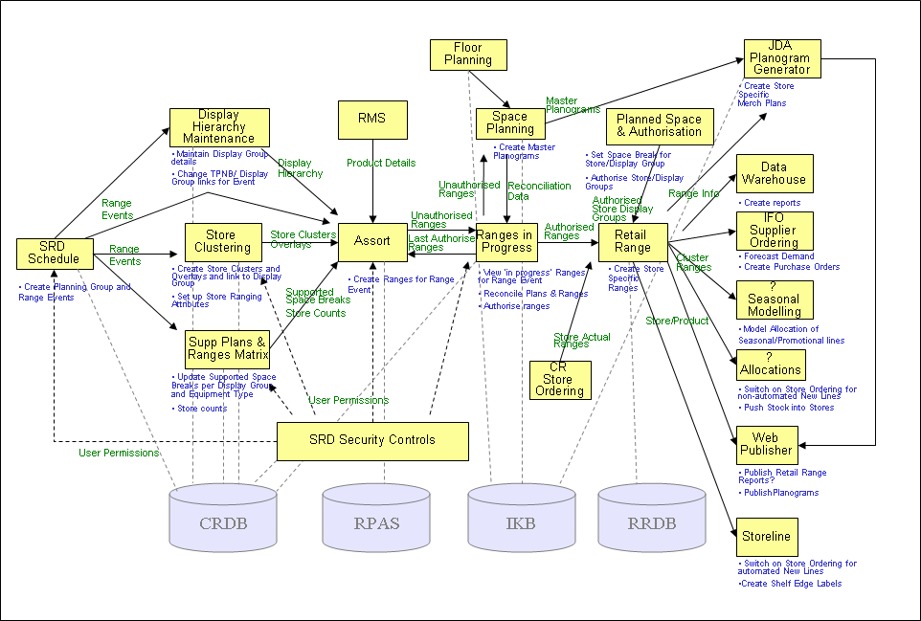
Fig n. UK Application Architecture and Supporting Data Structures

As a minimum the following SRD applications will be deployed on the following SRD databases:

Application | Supporting Database
SRD Schedule | Commercial Range Database
Display Group Maintenance | Commercial Range Database
Store Clustering | Commercial Range Database
Supported Plans and Ranges Matrix | Commercial Range Database
Ranges in Progress | Commercial Range Database
Ranging System/CRST | Accumate/Oracle RPAS
Floor Planning | Intactix Knowledge Base
Space Planning | Intactix Knowledge Base
Planogram Generation | Intactix Knowledge Base
Store Range | Store Range Database
Product Mapping | Product Mapping Database
Sales Aggregation | Sales Aggregation Database

Data Model
The logical data model for Space, Range and Display is as below. This is a composite of all the business functions. Detailed data models for each application will be included in the Detailed Solution Architecture.

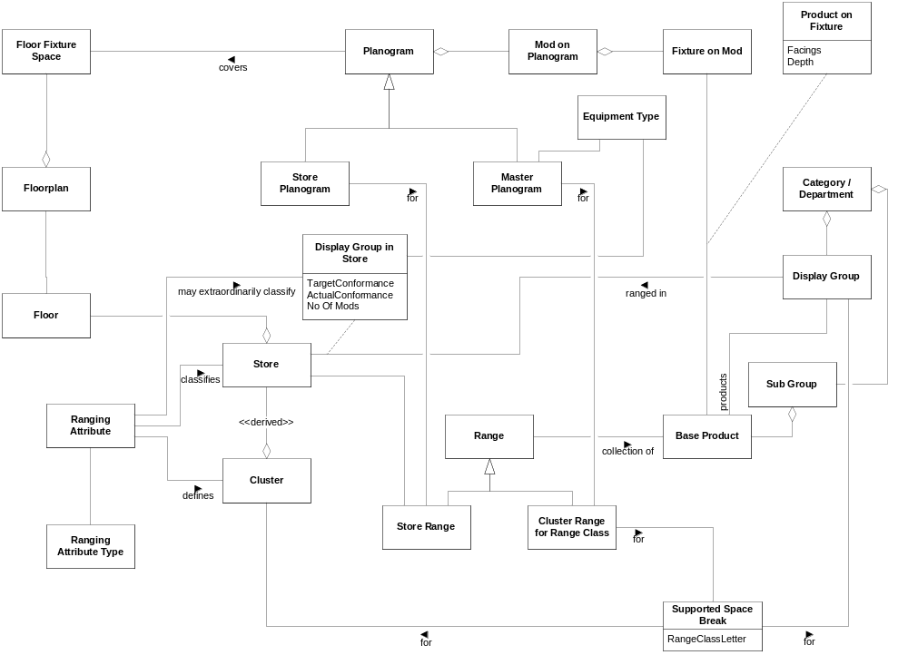

Entity Descriptions
The entity descriptions are as per the catalogue below.

Information Entity | Created By | Read By
Cluster Range for Display Group for Range Class | Ranging System | JDA Intactix, Ranges in Progress, (Store Specific Range)
Base Product |  | Ranging System, Range Controls, JDA Intactix
Sales History |  | Ranging System, JDA Intactix
Overlay | Ranging System | Ranges in Progress, (Store Specific Range)
Store |  | Range Controls, JDA Intactix
Business Calendar |  | Range Controls
Department |  | Range Controls
Display Group | Range Controls | Ranging System, Ranges in Progress, JDA Intactix, Data Warehouse, Supply Chain Systems, Commercial & Replenishment Systems
Cluster | Range Controls | Ranging System, Ranges in Progress, Data Warehouse
Event | Range Controls | Ranging System, Ranges in Progress, JDA Intactix, Data Warehouse, Space, Range & Display Portal
Range Class | Range Controls | Ranging System
Overlay Type | Range Controls | Ranging System
Planogram | JDA Intactix | Ranges in Progress, Storeline
Product on Fixture | JDA Intactix | Storeline, Commercial & Replenishment Systems
Department |  | JDA Intactix
Product on Fixture [actual] | Storeline | JDA Intactix
Sales |  | JDA Intactix
Store Range | (Store Specific Range) | Space, Range & Display Portal, Data Warehouse
Product in Range | (Store Specific Range), (Marketing) | Space, Range & Display Portal, Storeline, JDA Intactix, Data Warehouse, Supply Chain Systems, Commercial & Replenishment Systems
Floorplan | JDA Intactix | Space, Range & Display Portal
Planogram | JDA Intactix | Space, Range & Display Portal
Feedback | Space, Range & Display Portal | JDA Intactix
Display Group in Store | JDA Intactix | Range Controls

Solution stereotypes / patterns / services used
Not applicable for this level of documentation

Logical Infrastructure Architecture
The high level networking and security architectures are described below.

Networking
A projective network architecture has been developed. This belongs to TOM rather than Space, Range and Display. The interaction between this set of applications and the network will be determined in the detailed solutions architecture.
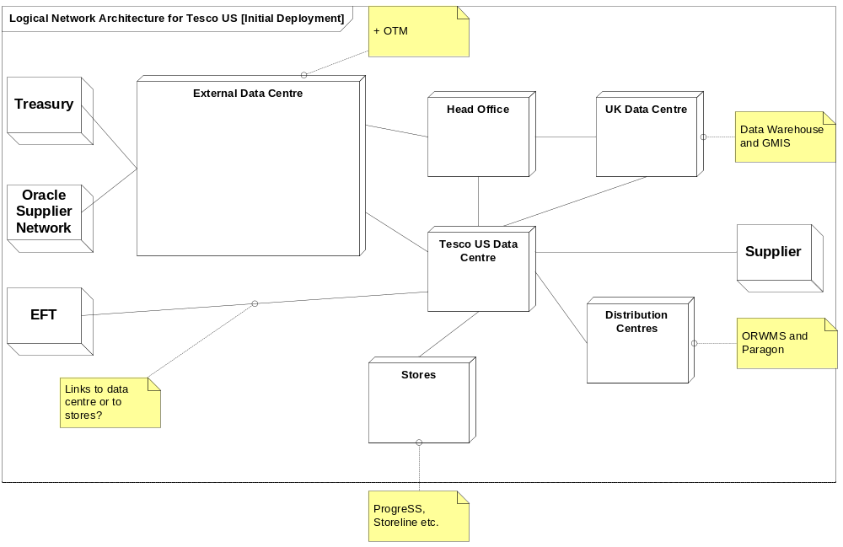

Security
The model that Tesco operates to for security is as below. Specific consideration will be taken over each element of the security model. In this model the bulk of the application will run internally so assumptions are made that the network and host are secure and the bulk of the effort will be expended on the inner components – particularly the application level.

From a security aspect we will manage:
- Network
- Host
- Application
  - Runtime services and components
  - Platform services and components
  - Operating System

Users will be authenticated by Active Directory. The use of generic logons is being phased out so each individual user will be uniquely identified.

The application runs entirely within the Tesco group network so this will diminish the absolute security requirement.

Particular solutions will be determined for each component or natural group of components in the application architecture. This will be dealt with in the detail solutions architecture.

Hardware
Not applicable to this document at this stage

Solution stereotypes / patterns / services used
Not applicable at this stage of the document

Physical Architecture

Physical Application Architecture
This document aims to define the logical core of the Space, Range and Display solution. The physical application architecture is determined on a country by country basis using the constraints and characteristics of that country. The logical application architecture is the basis for the generation of each physical application instance. A broad definition of each platform can be given but this will vary on an instance by instance basis. The entire solution is made from a collection of large components. The following section describes each of these large components and the sub-components that it is comprised of.

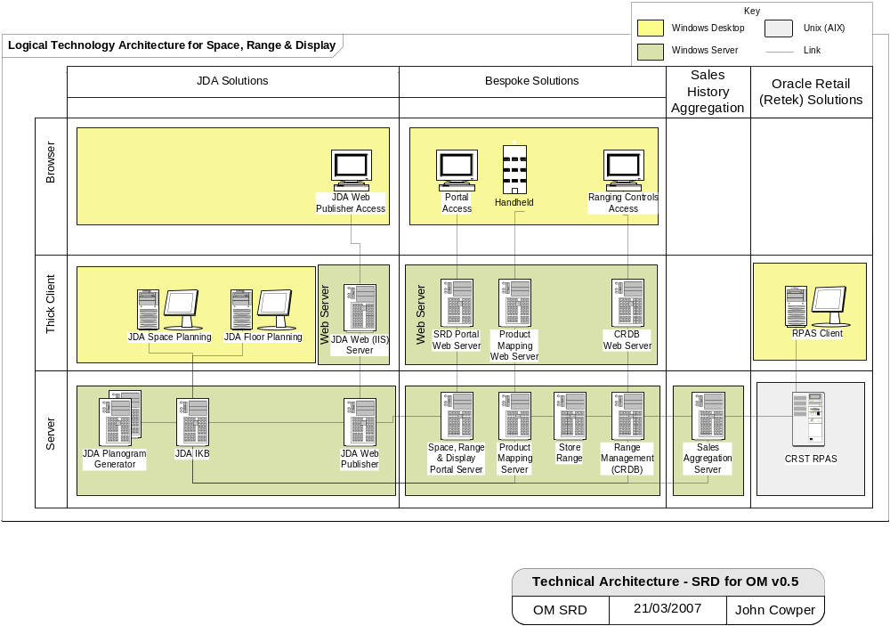
Fig n – SRD Logical Technology Architecture

Space, Range and Display applications are client/server based and are deployed geographically to a Data Centre, Display Centre and Stores. Specifications exist for each of these boxes, sized for each geography, and this is described in the detailed Solutions Architecture. The server applications comprise the following systems:

Data Centre Based Systems
These applications cover the key elements of the Space, Range and Display functionality (and should really be called Range, Space and Display). Space is the allocation of mods within a store to a particular Department. Range is the process of profiling stores and products and determining which products will be allocated to each store. Display is the process of placing the selected products on the mod in the most commercially effective manner.

- Range is managed within the Ranging System, Range Controls and Ranges in Progress applications
- Space is managed within the JDA Floor Planning application
- Display is managed by the JDA Planogramming application

Reporting is managed in the Store Range system. This takes data feeds from JDA, General Forecasting and Ordering (GFO) and Product Mapping (as well as reference data feeds from the integration layer).

Range

Range Controls
This is the name given to a set of Web Applications that enable users to manage the Range related framework information and schedule ranging activities. Typical activities include adding events to the Event Schedule, managing Display Groups and their associated Product Subclasses, managing Store Clusters and their associated attributes and Store Retail settings and controls and User Security. The information created through these Web Applications is stored in the associated CRDB database.

Ranging System
This system is an Oracle package application that is built on Oracle Retail Predictive Application Server (RPAS). It is a multidimensional database, with spreadsheet style workbooks and sheets for analysing data.
It is used by Buyers to model and create product ranges that are design for particular Display Groups and for particular Store Clusters.

Ranges in Progress
This is the name given to a set of Web Applications that enable users to manage the flow of Range information to the JDA Intactix suite for Floor Planning and Planogramming purposes and to initiate reconciliation between planograms and ranges.

Space & Display

JDA/Intactix
The principal object in the SRD application portfolio is the JDA Intactix database. This maintains the data structures required to run the SRD system.

In the UK model the data from each system is fed into the Store Specific Planogram service (SSPOGs). Within the Operating Model solution, the system of record for product in location is JDA. The association of ‘master’ Planograms with a Store specific floor plan creates the Stores centrally proposed range and when the planograms associated with a floor plan have all been authorised within Ranges In Progress then all stores that contain the newly authorised planogram can have their entire set of planograms sent to the Store Range application for onward dissemination to downstream dependent systems consisting of General Forecasting and Ordering application (GFO) (that uses the associated product capacity information), StoreLine (that uses Shelf Edge Label information) and Oracle RMS (that uses Product in Store (item/location) information.

Planogram Generation
Once the product in location data has been organised in the Intactix database system, this data is used by the Planogram solution. Store specific planograms are created which can then be viewed by the relevant stores.

Store Range
Store Range was modelled on the Retail Range database functionality as used in the UK. The data flows between the UK model and the Operating Model are quite significant. As a consequence, Store Range has been enhanced to include capacities and the ability to support multiply located products. Data from the main transactional systems (JDA, GFO and Product Mapping) will be located here and reporting and conformance calculated.

Product Mapping
Although Product Mapping is a store based application there is a central component to it. This is the database that supports the application.

Sales Aggregation
A number of systems within SRD require sales data. This is used to calculate the correct facings and also assess the sales performance of Products, Stores and Planograms. This data is highly application specific and so is not delivered from the integration layer. SRD have solved this by introducing the Sales Aggregation engine which receives requests for data and services that request overnight.

Space, Range and Display Portal
Space, Range and Display will deploy a SRD Portal application, to provide a store front-end (and single point of access) to all SRD services such as planogram publishing, store range change feedback, local ranging etc. Part of this will be delivered via the JDA Web Publisher application. All other applications will be delivered by the Tesco Store Portal. It is expected that a tactical version of the SRD portal will be delivered initially and that this won’t be delivered for phase 1.

For the Tesco Store Portal delivery, there are two basic technologies: Java-based and .NET-based. Tesco do not develop Java-based applications so, based on current Tesco application development standards, this application will be delivered as a 'standard' .NET web application. This is in lieu of having a strategy for store portal that would provide more direction on this. The JDA elements can be incorporated into the .NET TOM delivery.

There will be a US-specific store portal based on the Websphere Portal infrastructure used for the intranet portal. The JDA elements will need to be incorporated into the framework.

Note that in the early stages of the project it was assumed there would be a store portal within the operating model application architecture, but this is not now going to happen.

Store Based (Retail) Systems
Retail comprises the following systems:

Storeline
Storeline is the principal in-store application. Please refer to the Storeline development stream for additional details. Space, Range and Displays involvement with Storeline is limited to the production of Shelf Edge Labels (SEL). Product Mapping will collect the data that will drive the printing of SELs but Storeline will perform the actual printing.

Product Mapping
The handheld devices are a component of the Space, Range and Display solution. Data collected from these devices (Product Mapping) is used (by SRD) for assessing the conformance of the merchandised mods to the centrally proposed ranges. There is no requirement (for SRD) to retain this information at store so the design will be a thin client on the handheld device operating against a service on a store based server (potentially the same one that services Storeline) that messages on a store and forward basis to a central data repository. This is possibly JDA but more probably a separate data store.

Handheld Devices
Product Mapping is a newly developed application which exists on the handheld devices. The development of this application has been re-assigned from the Storeline development stream. Product Mapping is required to generate the Store Product Map. It will also be used to generate capacities for Stores within Countries where there is no planogramming capability. It will also be used to generate accurate shelf edge labels (SEL) where a discrepancy is identified between the actual product map and the information contained within the planogram.

The Product Mapping application recognises the maturity of the Display Group, Store and Country it is operating in. For Countries with no planogramming capability the functionality is tailored to allow collection of capacity by capturing height, width and depth of the product. This will be used in substitution of the planogram generated capacities. Where planogramming is being rolled out on a Display Group by Display Group basis, the system will know which Planograms will require full capacity collection and which Planograms require only facings collection. Where a store is fully planogrammed (but possibly the country isn’t) the application will only collect facings.

The application will be built as a thin (smart client) browser based application operating from the centre. This will require a continuous TCP/IP connection. The handheld will be able to operate for a period of time out of RF connectivity but this may require some remedial actions when connectivity is re-established.

The handheld devices are being built to GT&A full strategic standards. By using these standards there is an expectation that the difficulties with application roll out can be avoided. Adoption of the GT&A standards will also allow for any number of applications to be running on the handheld (as there is no permanent application resident and there is no transaction data permanency). The

A detailed specification of the Product Mapping application will be in the detailed solutions architecture.

The solution is designed to be handheld device independent. The solution allows for a common application communicating through a device specific linking layer. Turkey currently operate on Intermec 760’s (on Windows Mobile 2002 but upgrading to Windows Mobile 2003). The US is running on Symbol MC70’s (running Windows 2003 Mobile).

[China and Japan have Intermec 751 for pilot but will move to symbol before rollout.]

Reporting Systems

Data Warehouse
The data warehouse will be delivered as a service from the UK instance.

Local Application Reporting
Where operational reporting can be driven from local applications, these will be left to manage that reporting.

Operational Reporting
Cross application reporting will be delivered from this service. As yet there are no instances of cross application reporting that cannot be delivered either from the local application or the MIS Reporting service. On this basis, there is no firm requirement for this service to exist.

MIS Reporting
The bulk of the Space, Range and Display reports that have been identified so far that can’t be delivered from local applications. They will be delivered from the MIS Reporting service.

Enterprise Information & Integration Services Layer
A substantial amount of the data to drive Space, Range and Display will be delivered through the integration layer. In addition some functionality is driven from within the integration layer. Space, Range and Display is driven principally by aggregated sales information. This information cannot be driven from local systems eg Storeline. This data is then provided as a service through the corporate Enterprise services. The following services will be used by Space, Range and Display

Foundation Data Services
This is the reference data available in the service. Space, Range and Display will use the following objects:

- Product
- Product in Location at Price

Product in Location at Price was originally envisaged to be at Store level but this program has requested that this be brought down to shelf level. We have additionally requested multiple locations by product.

Transaction Data Services
This is the transactional data available in the service. Space, Range and Display will use the following objects:

- Sales History (2 year aggregated)
- Operational Sales History (2 week detailed)

Space, Range and Display require adjusted sales (for stock out, promotion). It is not certain that this can be provided by this service. Sales data will be passed to the Sales Aggregation engine for later processing into the particular formats required within the consuming systems.

Integration Services
This is the integration capability available in the service. Data provided to applications will require certain transformations and enhancements. Space, Range and Display use the following objects:

- Eg consolidation of shelf edge label data from multiple sources

Business/Operational Services
A number of business services will be utilised by Space, Range and Display. These will be described in the detailed solutions architecture.

Scheduling
Scheduling will be delivered as an operational service

Integration Layer
The integration layer will be an operational service. This will be delivered as a biztalk instance handling both XML (streamed data) and xxx (flat file transport).

Other Components
There are occasional omissions in the delivery of business services. These are identified as ‘yellow boxes’. This occurs where data required by a system from the integration layer is so specific that it will only be used by this system. In these cases a special function will be delivered to satisfy this requirement. The object will belong to the application rather than the integration layer.

Physical Information Architecture
Not applicable to this document at this stage

Physical Infrastructure Architecture
Not relevant at this stage

Deployment Architecture
Not applicable to this document at this stage

Development Architecture
The Space, Range and Display TOM Application will be built using standard Tesco Operating Procedures. In this respect all development will be executed in HSC to designs created by the UK Design Team (comprising the Solution Architect and the relevant GT&A Services: Enterprise Architecture, Information Architecture, and Infrastructure Architecture).

The application design will be tailored to individual design within HSC and this will accommodate the local variances. An example of this is the use of RMS version 10 in Turkey and the use of RMS version 12T in the US.

The application will be system tested within HSC but User Application Testing (UAT) will be carried out In-Country. There should be sufficient confidence in the scalability of the application before it is shipped for UAT.

Development Environments
Development
All development within this program is done as a service. The service providers for this program come from 4 agencies: HSC, Tata Consulting Services (TCS), Infosys and SysRepublic. The project will not deal directly with these teams but operate through Integation Services. Where development is performed by other groups on behalf of the project (specifically the IDS and Integration Services teams), the development environment will be provided by the appropriate development group.

Tailoring of the JDA toolset will be performed by JDA to Tesco requirements.

Space, Range and Display will adopt elements of code developed by the UK Space, Range and Merchandising team. Integration of this code into our solution will be performed by HSC.

Test
Three test environments are to be created for this program. This will cover Test, Integration and Patch. Due to the variances between the Turkish and US implementations consideration will need to be given to the different data sources. It is expected that the Integration Layer will moderate most of these differences but this needs to be proven in practice.

Further investigation will be required during design to establish how far through the down stream systems information needs to propagate during testing in order to establish a satisfactory level of confidence.

Staging
UAT will be performed in country.

Development Tools
Where development is performed by other groups on behalf of the project, the development tools will be selected by the appropriate development group.

Development within the SRD project will be .NET based, and thus will be a WOF (Wintel Operating Framework) based development. The tool of choice for this type of development is Microsoft Visual Studio (with C# as the language of choice).

Development Method
Where development is performed by other groups on behalf of the project, the development method will be selected by the appropriate development group.

The elements of development to be handled within the SRD project will follow a waterfall development approach.

Implementation Considerations
The US and Turkey application architectures differ. This may require some tailoring during implementation.

Operations Architecture
This section will describe how the operating model will be managed and supported.

The Space, Range and Display model will support the ITOF aspirations under a best efforts regime. The ITOF strategy is still formative and Space, Range and Display will support and enhance this strategy as can be best devised between the project and GT&A.

By layers, the ITOF model supports:

- Infrastructure
- Applications
- Information and Integration
- Business Processes

The Operating Model ultimate objective is to provide an uninterrupted Business Service. This is dependent upon securing the following four levels of the hierarchy. The following section covers the general principles. The detail of the support solution will be contained in the detailed level solutions architecture.

Infrastructure
The ITOF framework will allow for the monitoring of the underlying infrastructure components. This will cover:

- Servers
- Networks
- Network Components

Wherever a physical device writes to a log file or generates an SNMP trap the event will be recorded and will generate a corresponding alert. These will be routed through to the Operations Bridge.

Applications
Application monitoring will be provided by CA Unicenter. Unicenter Management enables the submission monitoring and management of jobs from a single location and will provide functionality to either alert administrators or automate corrective actions before end users are significantly affected.

Unicenter requires agents to run on the remote servers to be monitored. These remote agents pass back data to the central monitoring application.

Remote Management
The application and infrastructure support will conform to the Group Support Model. Its main provisions are:
- First level support to be provided by an in-country help desk, which is a shared resource across the entire local business
- Second level support to be provided by the in-country support team for that particular application. This team will also liaise with the local business and vendors
- Third level support will be central, currently split between the UK and HSC.

The Tesco guidelines for remote management are mostly based in CA management software thus making use of an enterprise-wide solution.

Information and Integration

Business Processes
The ultimate objective of the management and monitoring process is to provide robust, resilient systems. Details of how the operational processes support the operational and non-functional requirements will be detailed in the detailed solutions architecture.

Assumptions and Issues

Assumptions

ID | Assumption
1 | Wireless Networks are available in Store

Architecture Principles and Exceptions

This section highlights principles that have shaped the architecture or that cause issues.

Group IT Principles
Principle | Impact | RAG
Enhance the customer shopping experience | A fundamental consideration for Space, Range and Display is the creation of a range of products which is the best available. | G
Increase the capability of our people through better, simpler, cheaper stores | A fundamental principle of the (Tesco) Operating Model is to standardise processes. The very clear benefit from this is the conformity that this brings. By using standard processes, tools and technologies the offerings from the store becomes repeatable thereby allowing better service, simpler procedures and a cheaper model of operation. | G
Create an agile infrastructure to respond to business and systems change | The Space, Range and Display solution allows Tesco to deploy rapidly in a controlled and predictable manner. It isn’t necessarily an agile solution but it allows rapid scaling without losing control | A
Establish common back office systems and processes | A fundamental principle of the (Tesco) Operating Model is to standardise processes. | G

GT&A Application Principles
Principle | Impact | RAG
Future proof design | ?
Buy before build | The Space, Range and Display solution is a composite of in-house built technology and bought in technology. | A
Change the business process before changing the package | ?
One version of the truth | By replicating systems the ability to see ‘across’ the business is significantly enhanced. There is not one version of the truth but it is a substantial enabler to providing it. | G
Make the most of what we have paid for | By adopting the (Tesco) Operating Model the cost of development is spread across every site and geography | G
Think Group act Local | By creating a process model common systems can be created tailored to individual country and store requirements | G
Don’t fix it if it isn’t broken but take it away if possible | Space, Range and Display is a brand new system and therefore can’t be assessed on this point | -
Loosely couple applications and data | Making the data available in the Enterprise-Wide layer will allow us to avoid coupling any other systems to Space, Range and Display. | G
Make data available when needed | The infrastructure is designed to meet demanding service level requirements. | G
Common needs are delivered through common solutions, eg Operational Reporting |  | G
Drive down the cost of IT | The (Tesco) Operating Model will significantly reduce cost | G
Drive consolidation of platforms | The (Tesco) Operating Model will significantly consolidate platforms | G
Retain Intellectual Property in Tesco for competitive advantage | Space, Range and Display has a significant competitive advantage component in the ability to store proposed and actual ranges | G

Figure n: Adherence to Architectural Principles

Reference | Exception

Risks
ID | Risk

Appendix

Requirements Traceability
NOT COMPULSORY FOR TRIALS.

Create a matrix that records which elements of the architecture address which requirements. (This assumes that the requirements are presented as a numbered list.)

Requirement ID | Element of Architecture
00001 | Text

Document Control
Change Record

Author | Date | Version | Change Reference, description
John Cowper | 14 11 2006 | v0.0.0 Draft | First issue
 |  |  | Bsds, brds

Distribution and Sign-Off

Name | Position | Approver/  Contributor/Other | Sign-Off Date
Mike Yorwerth | Director, Group Technology and Architecture | Approver
Ann Merritt | Lead Architect, Information Services | Approver
Nathan Smith | Lead Architect, Information Services | Approver
Jonathan Summerfield | Lead Architect, Commercial | Approver
Gary Lewis | Enterprise Architect,  Space Range and Display | Approver
Eleanor Koniecko | Enterprise Architect,  Space Range and Display | Approver
Charlie Hope-Lang | Lead Architect, Infrastructure | Approver
Mark Goddard | Business Systems Manager, TOM Applications | Approver
Eva Hotmarova | Business Systems Manager, SRD | Approver

